Use Case: Triage Agents.
Contents
Use Case: Triage Agents. 1
Agent definition 2
Triage process - 3
Single-Agent System 4
Multi-Agent system 6
Agent 1: The "JR Auditor" (Stateful Refinement Agent) 6
Agent 2: The "Talent Strategist" (Optimization Agent) 6
Azure Resources 8
Data readiness 9

Agent definition
An AI agent is a
- Goal-driven system that,
- Perceives inputs from its environment,
- Uses memory (short-term, long-term, and semantic),
- With reasoning and planning to decide,
- and execute actions through tools,
- observes feedback,
- and adapts its behaviour to achieve objectives.
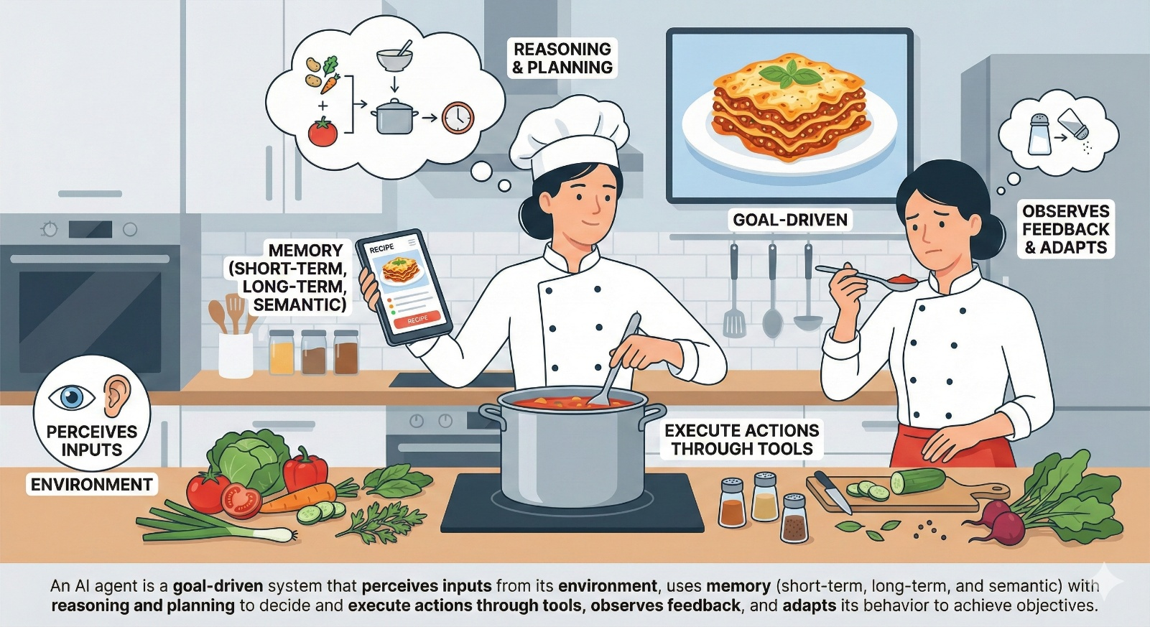
AI generated image

Triage process -
- Historical JRs are stored in Vector Database.
- New JR is raised by Delivery Team.
- Match new JR Description, Role, Track, Grade and identify delta in specifications mentioned in new JR vs Past JRs.
- If delta identified send an email stating JR correction required to Delivery Team.
  - Optional: If delta identified end the process.
- If no delta identified then, based on below mathematical model select top recruiter to whom we can assign the JR.
Mathematical Model:
A: Recruiter skills
- Defines the core recruiting area of recruiter for example data science.
B: Recruiter availability
- Defines how many current JRs the recruiter is working on.
C: Recruiter wins w.r.t specific JR
- Defines how many similar JRs won (definition of won in this case is JR accepted, completed and employee onboarded)
score = (0.3*A) + (0.4*B) + (0.3*C)
- Create a Microsoft teams’ group with Recruiter + Delivery Team Manager; Put entire JR in the teams, here recruiter can ask for clarifications.
- Once this group is created, process ends.

Single-Agent System
- Perceive (The Trigger)
  - The agent monitors the "New JR" queue.
  - Input: Receives a JSON object containing JR Description, Role, Track, Grade.
- Memory & Reasoning (Phase 1: Validation)
  - Semantic Memory (Long-term): The agent converts the new JR description into an embedding and queries the Vector Database.
  - Query: "Retrieve top 5 historical JRs with similar Role and Track."
- Reasoning (The "Brain"):
  - The Agent compares the New JR vs. Historical JRs.
  - Observation: "The user requested a 'Senior Data Engineer' (Grade 5) but the budget and skills listed align with historical 'Junior Data Analysts' (Grade 3)."
  - Decision: "I cannot proceed. If I assign this now, the recruiter will fail. I must resolve this ambiguity."
- Action & Tools (The Intervention)
  - Tool: send_clarification_email
  - Action: The Agent constructs a specific email:
"Hello, I noticed a deviation. You asked for Grade 5, but the skills align with Grade 3. This typically leads to a 20% delay in hiring. Do you want to (A) Lower the Grade or (B) Update the skills to include advanced requirements like Spark/Architecture?"
- Feedback & Adaptation (The Loop)
This is the critical "Agent" part. The process doesn't die; it waits.
  - Feedback: The Delivery Manager replies: "Option B. I forgot to add Spark optimization."
  - Adaptation:
  - The Agent does not start over. It uses Short-term Memory to recall the previous context.
  - It updates the JR object in its memory: JR.skills.append("Spark Optimization").
  - It re-runs the validation logic. Result: "Now the JR is valid."
- Reasoning (Phase 2: Optimization)
Now that the data is clean, the Agent switches context to Logistics.
  - Reasoning: It needs to pick a recruiter.
  - Tool: get_recruiter_data
  - Math Model Execution:
  - It fetches data for Recruiters X, Y, Z.
  - Note on Formula: I assumed a correction to your formula to utilize all variables:
    - Score = (0.3 * Skills) + (0.4 * Availability) + (0.3 * Wins).
  - Calculation:
    - Recruiter Alice: Great Skills (10), Low Availability (2), High Wins (8). Score = 3 + 0.8 + 2.4 = 6.2
    - Recruiter Bob: Good Skills (8), High Availability (9), Medium Wins (6). Score = 2.4 + 3.6 + 1.8 = 7.8
  - Decision: "Bob is the optimal choice because Alice is bottlenecked (Availability is weighted highest at 0.4)."
- Final Action
  - Tool: create_teams_channel
  - Action:
  - Creates Group: "JR-[ID]-Bob-DeliveryMgr"
  - Posts the cleaned JR summary into the chat.
  - Tags Bob: "You have been assigned based on your availability and win rate with similar roles."

Multi-Agent system
Agent 1: The “JR Auditor” (Stateful Refinement Agent)
Agent 2: The "Talent Strategist" (Optimization Agent)

Agent 1: The "JR Auditor" (Stateful Refinement Agent)
- Perceive: Reads the new JR.
- Memory Recall: Queries Vector DB for past JRs (Semantic Memory).
- Reasoning:
  - Observation: "The user asked for a 'Data Scientist' but listed 'ReactJS' as a primary skill."
  - Thought: "This contradicts historical patterns. Is this a 'Full Stack' role disguised as Data Science? If I pass this to a recruiter, they will be confused."
  - Plan: "I need to ask the user to clarify the primary role before I allow this to proceed."
- Action (Tool): Uses ask_clarification_tool to ping the user on Teams.
- Observe Feedback (The "Adaptation"):
  - Scenario A: User says "It's a mistake, remove ReactJS." -> Agent updates JR.
  - Scenario B: User says "No, we need a dashboard built." -> Agent adapts: "Okay, I will re-classify this as 'Data Engineer' which fits our recruiter skills better." (This is adaptation).
- Goal Achieved: JR is marked "Clean."

Agent 2: The "Talent Strategist" (Optimization Agent)
  - Perceive: Receives the "Clean JR" from Agent 1.
  - Tool Use: Runs the recruiter_ranking_model (the formula you provided).
  - Reasoning (The "Brain"):
    - Observation: "Alice is ranked #1 (Score 9.0), but Bob is #2 (Score 8.8)."
    - Memory/Environment Check: Checks Calendar/Status. "Alice has 5 active JRs (High Load). Bob has 1."
    - Thought: "Even though Alice has a higher skill match, her availability suggests a risk of delay. The score formula didn't weigh 'Burnout' high enough. I will override and pick Bob to ensure speed."
======= Observation Example 2 =============
- Observation: "Alice is #1 score, but she is OOO (Out of Office) for the next 2 weeks."
- Adaptation: "I cannot assign Alice despite the math model. I will check Recruiter Bob (#2)."
- Action: Assigns to Bob.

  - Action: Creates the Teams Channel.
  - Observe Feedback: Checks if Bob accepts the invite or posts a "Busy" status.
  - Adaptation: If Bob declines, the Agent automatically triggers the fallback plan (Assigns Alice) without human intervention.

Azure Resources
- Core Platform Resources
  - Azure AI Foundry Hub & Project:
    - Purpose: The central workspace where your Agent, Models, and Data Indexes live.
    - Action: Create 1 Hub and 1 Project in ai.azure.com.
- The Brains
  - Azure OpenAI Services
    - gpt-4o: For the Agent’s reasoning, planning, and tool calling.
    - text-embedding-ada-002: For vectorizing the historical JRs.
- Memory (Vector Data)
  - Azure AI Search Service (Connected to Foundry)
    - Feature: "Indexes" (in Foundry UI)
    - Role: This becomes the Agent's "Knowledge Base" (Semantic Memory).
- The Agent Runtime Azure AI Agent Service)
  - "Agents" (Preview in Foundry)
    - Instead of hosting a Python script on Azure Functions, you use the managed Azure AI Agent Service.
- The Tools (External Connections)
The Agent in Foundry needs "Actions" to talk to the outside world (SQL & Teams).
  - Azure SQL Database: (For Recruiter Math Data)
    - Connection: You define a "Function Tool" in the Agent that executes a query against this DB.
  - Azure Logic Apps: (For Email & Teams)
    - Connection: Export the Logic App definition as an Open API spec (Swagger) and import it as an "Action" in the Foundry Agent. This lets the Agent "know" how to send an email.

Data readiness
- 10 JSON files as past JRs, for History (Upload to Azure AI Search).
- 1 SQL Table with columns,
  - RecruiterID
  - Name
  - Email
  - CoreSkillArea
  - SkillScore
  - ActiveJRs
  - Wins
  - IsOOO

